**Task 21: Install Prometheus and Grafana on EC2 machine, connect Prometheus to Grafana, and create a dashboard to view metrics.**

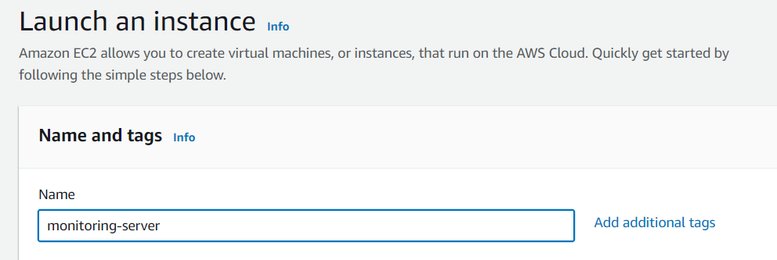

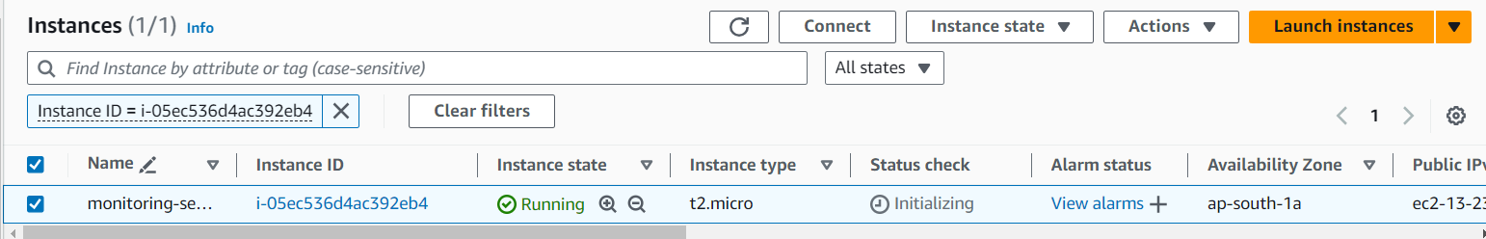

Connect that instance

1. **Install Grafana:**

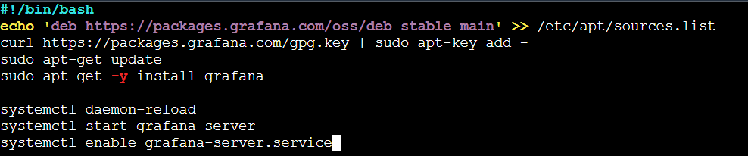

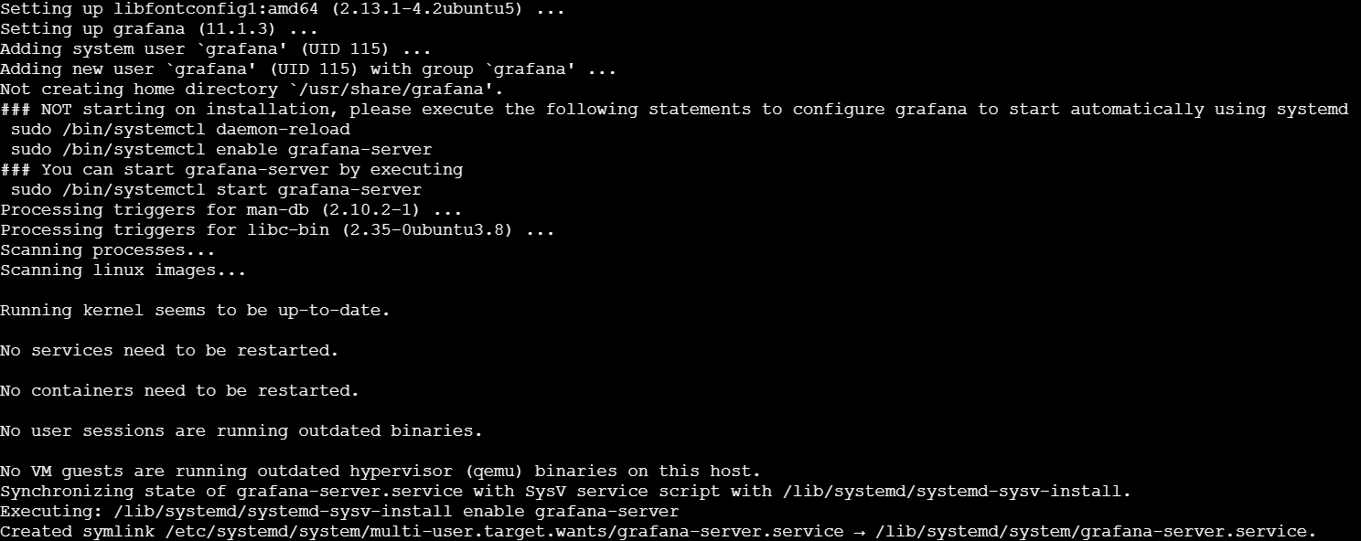

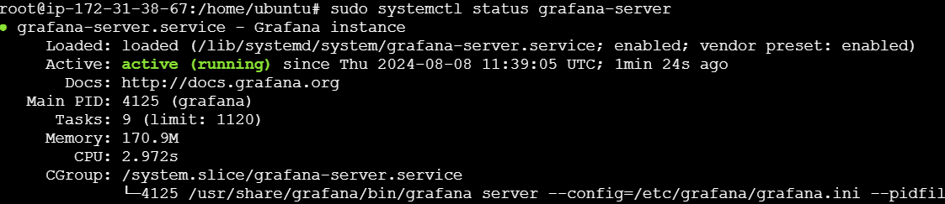

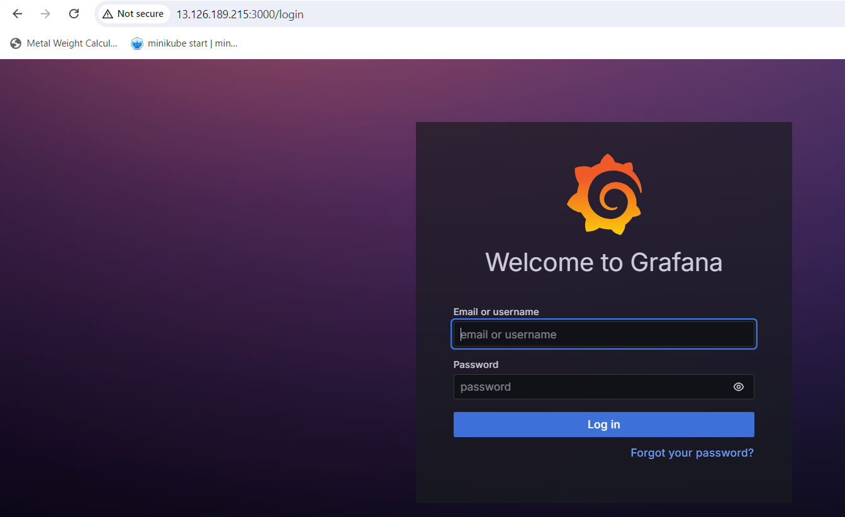

1. **Install Prometheus:**

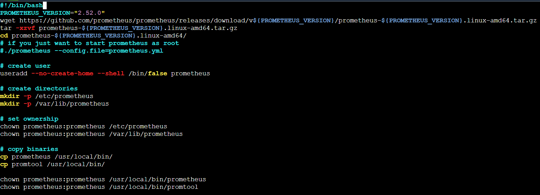

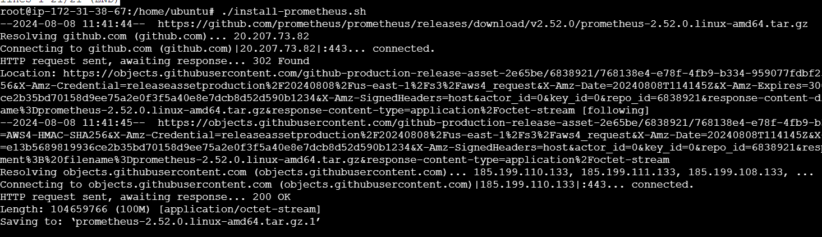

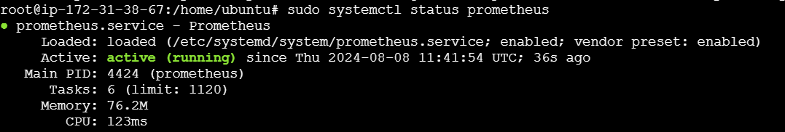

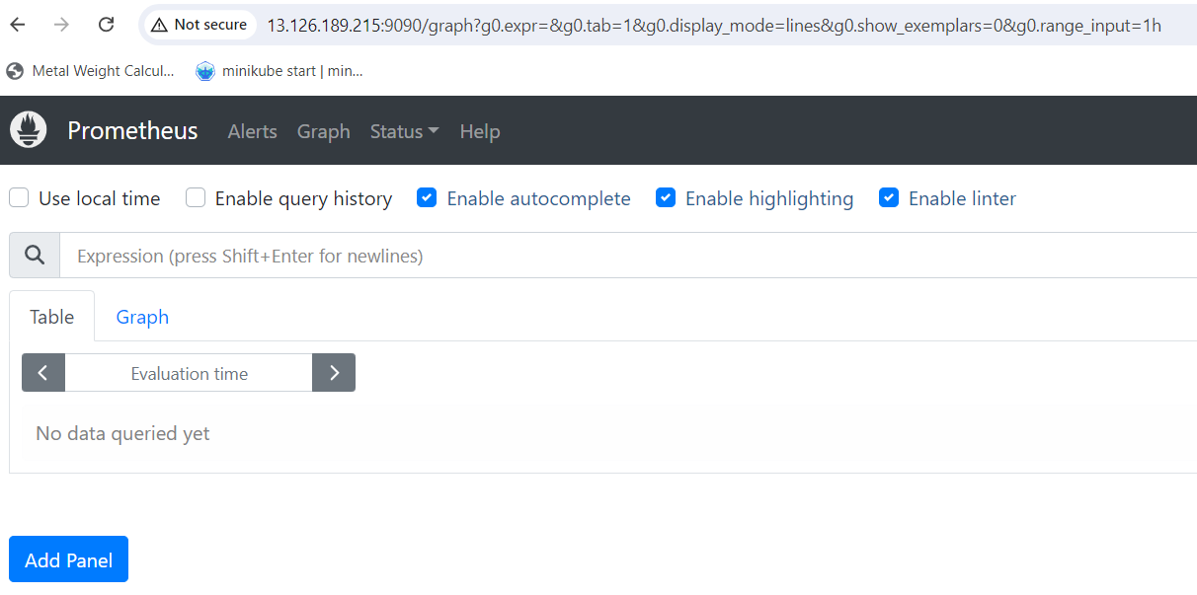

1. **Install node exporter:**

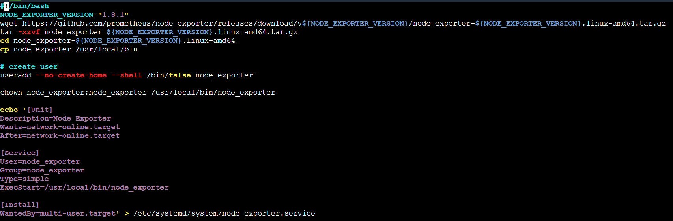

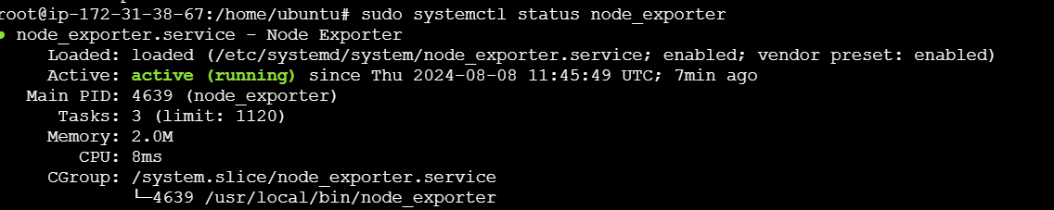

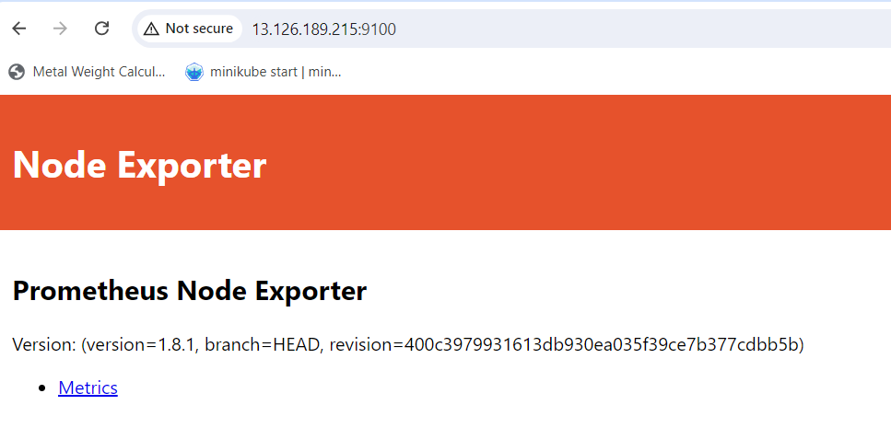

**Add port number for all**

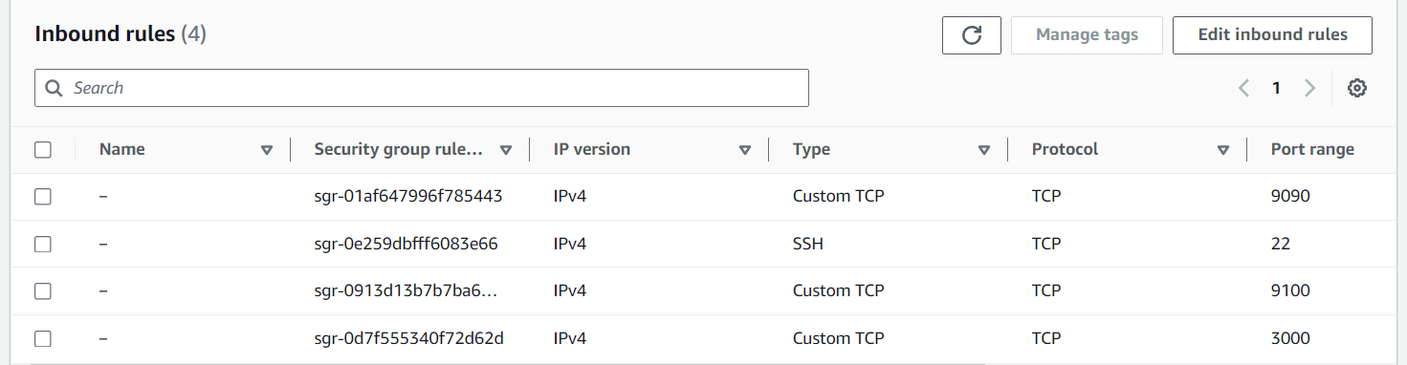

1. **create a dashboard to view metrics:**

**add source [Prometheus] in Grafana:**

